11PYTHON ACTIVITY-BASED LEARNING
Case Study 1: Retail Billing with Multiple Discount Rules
Name:Ganji Sreevalli
Roll Number:26000900
Branch: CSE (AIML)
Subject: Python Programming
1. Problem Statement
To develop a Python program that calculates a retail bill for multiple products based on their quantities, prices, category-specific tax rates, and discount rules. The program generates an itemized bill showing the subtotal, discount, tax, and final amount.
2. Objectives
- To calculate the total price of multiple products.
- To apply a discount when the subtotal reaches the required threshold.
- To limit the maximum discount amount.
- To calculate tax according to each product's category.
- To display an itemized bill and the final payable amount.
3. Assumptions
- Notebook price: ₹50, tax rate: 5%.
- Pen price: ₹10, tax rate: 5%.
- School bag price: ₹500, tax rate: 12%.
- A 10% discount is applied when the subtotal is ₹100 or more.
- The maximum discount is ₹200.
- Discount is distributed proportionally among products before calculating tax.
- Negative quantities are treated as zero.
4. Algorithm
- Start the program.
- Store product names, prices, categories, and tax rates.
- Ask the user to enter the quantity of each product.
- Treat negative quantities as zero.
- Calculate each product's amount and the subtotal.
- Check whether the subtotal qualifies for a discount.
- Calculate the discount and apply the maximum discount limit.
- Calculate each product's tax after its share of the discount.
- Calculate the final bill.
- Display the itemized bill, subtotal, discount, tax, and final amount.
- Stop the program.
5. Flowchart
ssssss
6. Pseudocode
START
Store product details
Set subtotal = 0

FOR each product:
Input quantity
IF quantity < 0:
Set quantity = 0
Calculate product amount
Add amount to subtotal
Store item details
END FOR

Set discount = 0
IF subtotal >= 100:
discount = subtotal × 10 / 100

IF discount > 200:
discount = 200

Set total_tax = 0

FOR each product:
Calculate proportional item discount
Calculate taxable amount
Calculate tax using product tax rate
Add tax to total_tax
END FOR

final_amount = subtotal - discount + total_tax
Display itemized bill and final amount
STOP
7. Python Source Code

# Case Study 1: Retail Billing with Multiple Discount Rules

products = [
("Notebook", 50, "Stationery", 5),
("Pen", 10, "Stationery", 5),
("School Bag", 500, "Accessories", 12)
]

subtotal = 0
bill_items = []

print("===== RETAIL BILLING SYSTEM =====")

# Get product quantities
for product in products:
name, price, category, tax_rate = product

quantity = int(input("Enter quantity of " + name + ": "))

if quantity < 0:
print("Invalid quantity. Using 0.")
quantity = 0

amount = price * quantity
subtotal = subtotal + amount

bill_items.append(
(name, quantity, price, amount, tax_rate)
)

# Calculate discount
discount = 0

if subtotal >= 100:
discount = subtotal * 0.10

# Maximum discount limit
if discount > 200:
discount = 200

# Display bill
print("\n========== ITEMIZED BILL ==========")
print("Product Qty Price Amount")

for item in bill_items:
name, quantity, price, amount, tax_rate = item

print(name, " ", quantity, " Rs.", price,
" Rs.", amount)

print("-----------------------------------")
print("Subtotal: Rs.", round(subtotal, 2))
print("Discount: Rs.", round(discount, 2))

# Calculate category-specific tax after discount
total_tax = 0

for item in bill_items:
name, quantity, price, amount, tax_rate = item

if subtotal > 0:
item_discount = discount * amount / subtotal
else:
item_discount = 0

taxable_amount = amount - item_discount
item_tax = taxable_amount * tax_rate / 100
total_tax = total_tax + item_tax

print("Tax: Rs.", round(total_tax, 2))

final_amount = subtotal - discount + total_tax

print("-----------------------------------")
print("FINAL BILL: Rs.", round(final_amount, 2))
print("Thank you for shopping!")

8. Test Cases
Test | Notebook quantity | Pen quantity | Bag quantity | Expected final bill
1 | 2 | 3 | 1 | ₹626.85
2 | 1 | 0 | 0 | ₹52.50
3 | 0 | 0 | 1 | ₹504.00
4 | -1 | 1 | 0 | ₹10.50
5 | 0 | 0 | 0 | ₹0.00

9. Output Screenshots
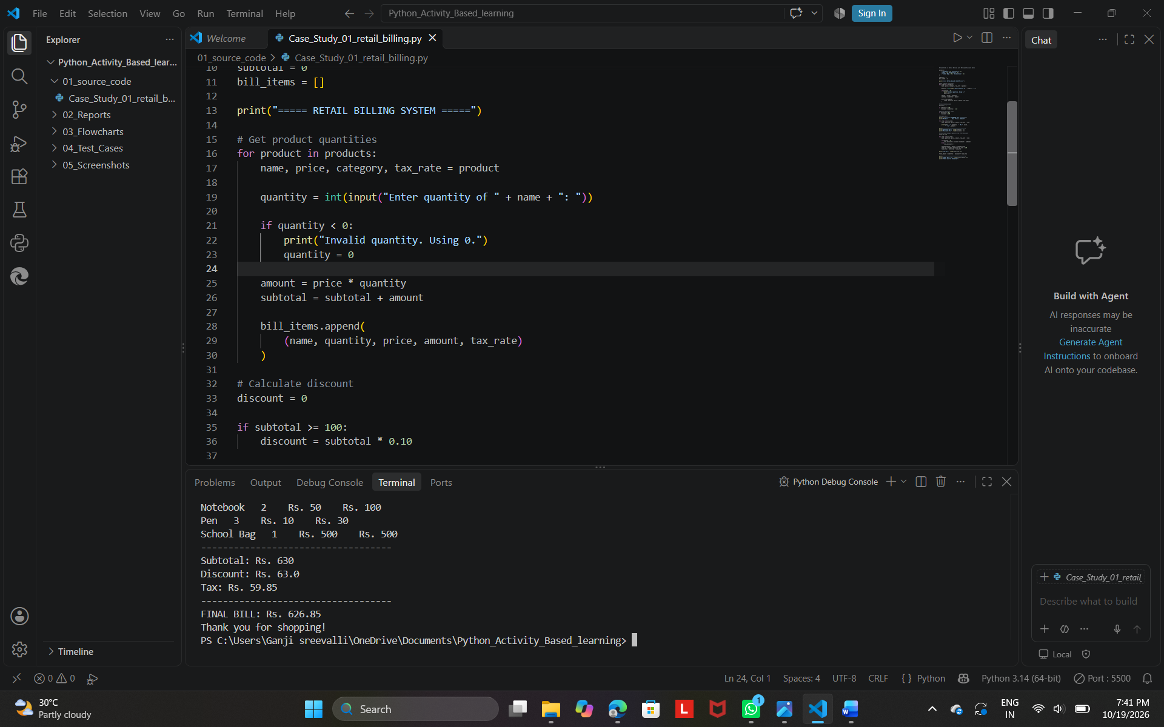
10. Conclusion
The Retail Billing System successfully calculates product amounts, applies discount rules, calculates category-specific taxes, and displays the final bill. This case study demonstrates the practical use of Python variables, lists, loops, conditional statements, arithmetic operations, and user input.

